Final Project implementation of 16-bit and 32-bit processors in Logisim and Vivado

Hutton Amison-Addy Victor Quagraine Delali Nsiah-Asare

Ashesi University

CS331_A: Computer Organization and Architecture

Dr. Robert A. Sowah

05/08/2024

# Part A: Logisim implementation of 16-bit Processor

## Overview

The project required the development of a 16-bit CPU in Logisim. The circuit involved eight and 16-bit registers for Instruction, Output, A program and Step counter, Memory address and bus, as well as 2 data registers, an ALU circuit, a RAM to load in instructions for use in the CPU and a decoder for displaying onto a 7-segment display output.

## Challenges

The primary challenge faced involved debugging the circuit due to the number of components used.

## Implementation

1. CPU Design Architecture

Instruction Register (IR) 16-bit

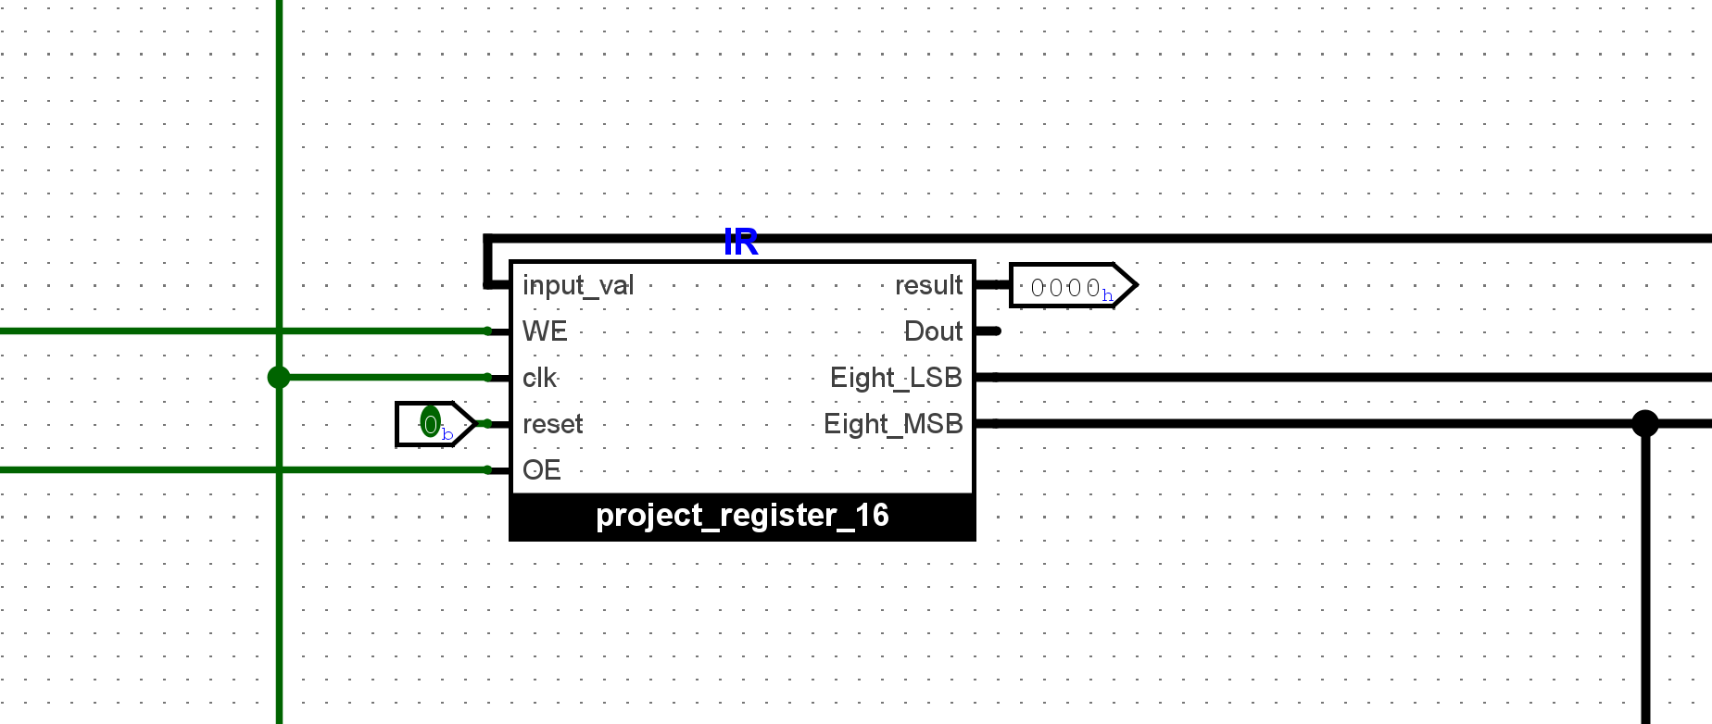

Arithmetic Logic Unit (ALU) 16 bits

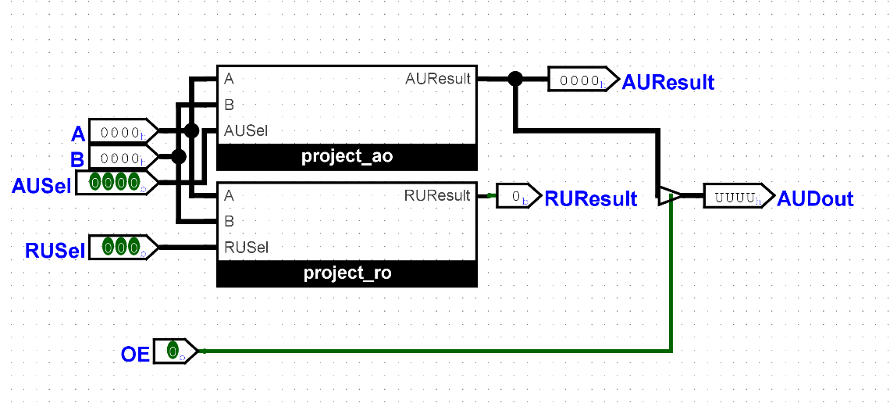

16-bit-Register (Output Register, RegA, RegB, MBR)

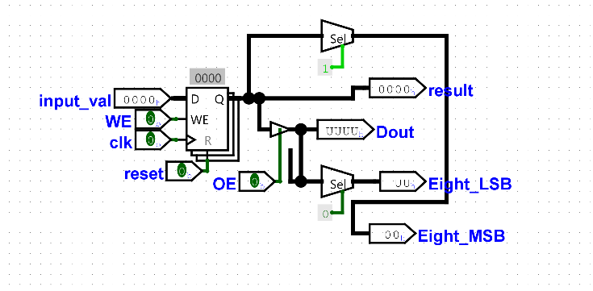

8-bit-Register (MAR)

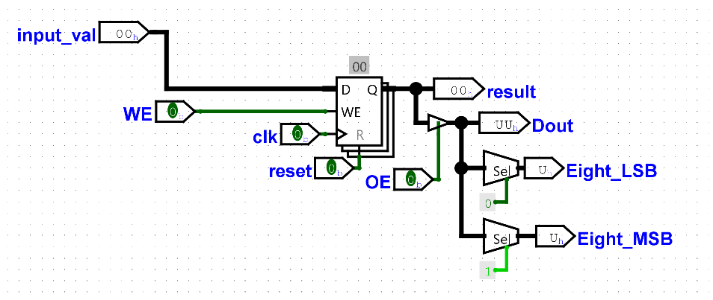

1. Datapath Design
   1. Instruction implementation loaded into the RAM

|  |  |  |  |
| --- | --- | --- | --- |
| **Memory Address** | **Content** | **Hex** | RAM Instruction form |
| 0000 | **00000000 00001010** | 0x00 0x0A | 000a |
| 0001 | 00000001 00001101 | 0x01 0x0D | 010d |
| 0010 | 00000010 00000000 | 0x02 0x00 | 0200 |
| 0011 | 00000011 00001010 | 0x03 0x0A | 030a |
| 0100 | 00000000 00000000 | 0x00 0x00 |  |
| 0101 | 00000000 00000000 | 0x00 0x00 |  |
| 0110 | 00000000 00000000 | 0x00 0x00 |  |
| 0111 | 00000000 00000000 | 0x00 0x00 |  |
| 1000 | 00000000 | 0x00 |  |
| 1001 | 00000000 | 0x00 |  |
| 1010 | 00001010 | 0x0A | 000a |
| 1011 | 00000000 | 0x00 |  |
| 1100 | 00000000 | 0x00 |  |
| 1101 | 00001111 | 0x0F | 000f |
| 1110 | 00000000 | 0x00 |  |
| 1111 | 00000000 | 0x00 |  |

1. Simulation and Testing

Figure 1: RAM after 3 iterations of the instructions provided

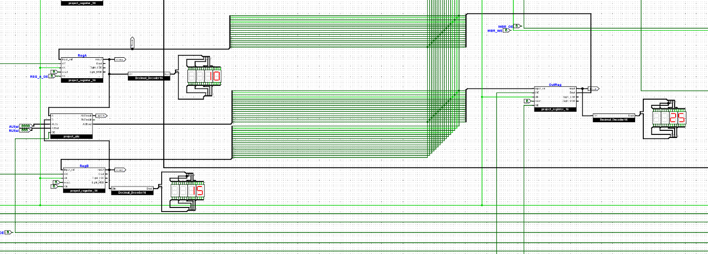

# Part 2: VHDL Implementation of a 32-bit Processors

## Overview

The Project expands on the previous part, building a 32-bit processor with implementation in VHDL. We used Vivado to simulate the output through a testbench.

## Challenges

Everything. The implementation of branch instructions caused an error with ALU outputs. We were unsure about the assignment of opcodes for the ALUop, ALU operations, in the control unit file.

## Result of Simulation

Figure 2: Instruction 0

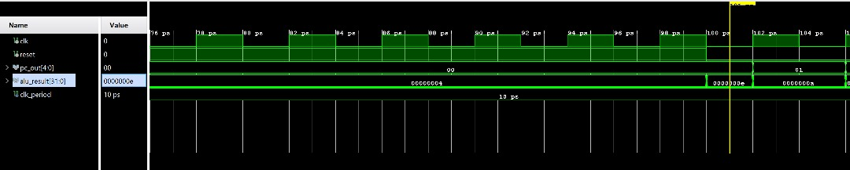

Figure 3: Instruction 1

Figure 4: Instruction 2

Figure 5: Instruction 3

Figure 6: Instruction 4